Basic Quantum Chemistry Reference
Compiled By: Matthew Rowley

Table of Contents
- Particle in a Box
- Harmonic Oscillator
- Rigid Rotor and Spherical Harmonics
- Hydrogenic Atom
- Intro to Many Electron Atom
- Variational Theory
- Linear Variational Theory
- Non-Degenarate Perturbation Theory
- Degenerate Perturbation Theory
- Definite and Indefinite Integrals
- Physical Constants and Conversions
- Notes and Acknowledgements

Particle in a Box
= 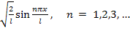

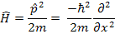

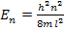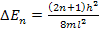

3-Dimensional Particle in a Box
= 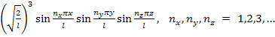

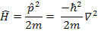

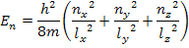

Harmonic Oscillator
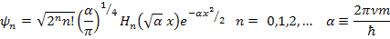

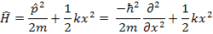

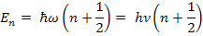

Hermite Polynomials
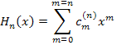

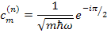

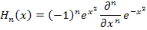

Ladder Operators
;

;

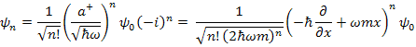

The First Few Normalized Wave Functions
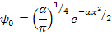

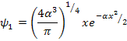

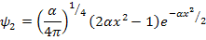

Alternate General Form of the Wave Function
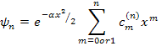
Note that only even or only odd terms are included in the sum
For n = even,
For n = odd,

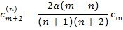

The entire wave function must be normalized after the summation

Rigid Rotor and Spherical Harmonics

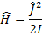

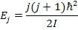

Spherical Harmonics

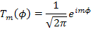

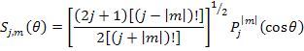

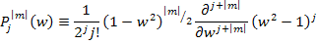

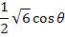
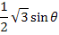
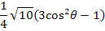
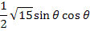
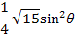
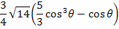
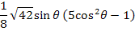
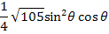
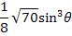

Angular Momentum Operators
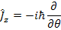

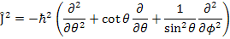

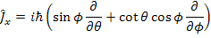
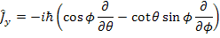

Ladder Operators

Hydrogenic Atom
Wave Functions

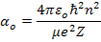

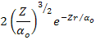
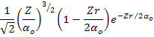
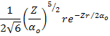
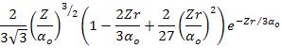
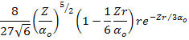
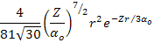

Complex Hydrogenic Wave Functions
1s | 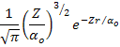
 | 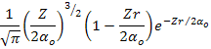
 | 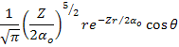
 | 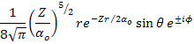
3s | 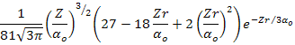
 | 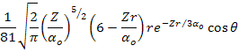
 | 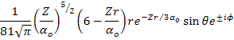
 | 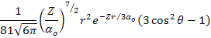
 | 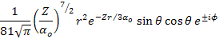
 | 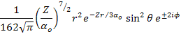

Real Hydrogenic Wave Functions
1s
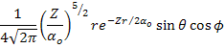
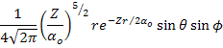
3s
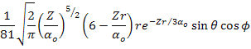
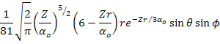
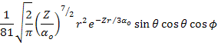
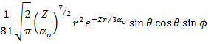
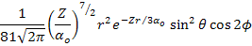
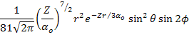

Hamiltonian
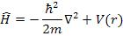

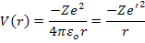

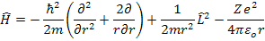

Energies
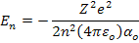
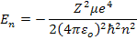
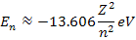

Intro to Many Electron Atom
Wave Functions
For Ground State Solve the Slater Determinant:
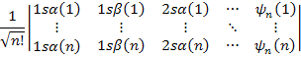

Hamiltonian

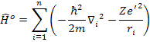

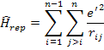

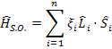

Term Symbols for Equivalent Electrons
Configuration | Terms
Term Symbols for Nonequivalent Electrons
Configuration | Terms

Variational Theory
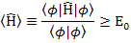

Linear Variational Theory
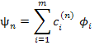

Energies
To find E_{n} solve for W in the secular equation:
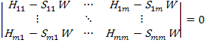
This gives roots of W, corresponding to the upper bounds of the m lowest energy states.

Wave Functions
To find and solve this system of equations:
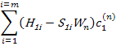
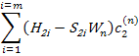
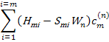
Because the above system is not completely linearly independent (by one degree) we must finally normalize by:
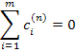

Non-Degenerate Perturbation Theory
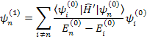

The First Few Degrees of Energy Correction

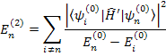

Degenerate Perturbation Theory
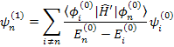

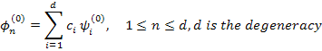

Finding Correct Zero-Order Wave Functions
To find , solve the secular equation:
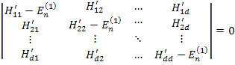

The First Few Degrees of Energy Correction

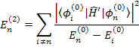

Definite and Indefinite Integrals
Remember that
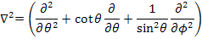

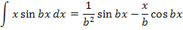
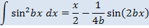
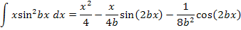
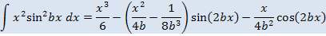
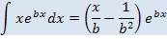
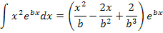
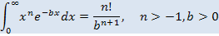
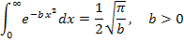
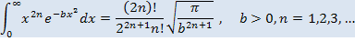

Physical Constants and Conversions
Constant | Symbol | SI Value | Gaussian Value
Speed of Light in Vacuum | c
Proton Charge | e
″ | e'
Vacuum Permittivity |  | 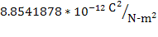
Avogadro Constant
Electron Rest Mass
Proton Rest Mass
Neutron Rest Mass
Planck Constant | ℎ
Reduced Planck Constant | ℏ
Faraday Constant | F
Vacuum Permeability
Bohr Radius
Bohr Magneton |  | 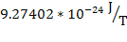
Nuclear Magneton |  | 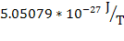
Electron g Value | g_{e}
Proton g Value | g_{p}
Gas Constant | R | 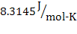
Boltzmann Constant | k | 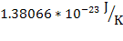
Gravitational Constant | G | 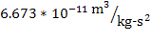 | 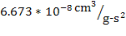

Energy Conversion Factors

Notes and Acknowledgements:
- Spherical coordinates are represented in the way standard for chemists (which is different from the standard used by mathematicians). i.e. r = radius from origin, angle with the positive z axis, angle between the positive x axis and the projection onto the x/y plane.
- This reference sheet was written shortly after I finished an introductory quantum chemistry course in my senior year. It was originally meant to help me remember that course in years to come, and while the quality standards have increased the scope has remained the same. It will not likely be helpful at all to one who does not already understand how to use these equations.
- While I have worked hard to ensure that this document is correct, I assume no responsibility for the accuracy of the information here.

The following were used in compiling this reference:
- http://panda.unm.edu/Courses/Finley/P262/Hydrogen/WaveFcns.html
- Levine, Ira N. Quantum Chemistry 6th ed. Pearson Prentice Hall (Upper Saddle River, NJ) 2009.
- Hollas, J. Michael. Modern Spectroscopy. John Wiley & Sons, Ltd. (Chichester, West Sussex, England) 2004.

